How Does the NBA's Second Apron Reshape Mid-Level Veteran Labor?

Andy Daileanes
ECO 329: Dr. Smith — Davidson College
April 29, 2026

Abstract
This paper asks how the NBA's second apron reshapes the allocation and composition of mid-level veteran labor. Using a player-season panel of 3,645 observations spanning 15 seasons from 2011-12 through 2025-26, I estimate player fixed-effects models separately for three labor groups. Following the implementation of the second apron, I find that mid-level veterans lost 3.2 minutes per game (p=0.001), were significantly moved from starting to bench roles (p=0.007), and played in fewer games (p=0.035). High-salary veterans' minutes declined modestly (-0.74 MPG, p=0.024) and rookie-scale players started more frequently (+0.065, p=0.045). Beyond utilization, the mid-level salary band shifted significantly toward younger, earlier-career players post-apron (chi-square p=0.005), driven by more year-4 rookies entering the band (37.5% vs. 29.3% pre-apron) rather than the exit of older veterans. Additionally, the players who remain in the band are better — prime-age (27-30) average BPM improved from -0.56 to +0.43 — consistent with a selection effect in which only truly productive prime-age players now command mid-level contracts.
I. Introduction
1.1 Context and Why It Matters
The NBA features an escalating regulatory cost structure designed to promote competitive balance. At its foundation is a soft salary cap; teams can exceed it, but face rising financial penalties as they do. Once a team's payroll crosses the luxury tax threshold, every additional dollar triggers a per-dollar penalty starting at $1.50 and increasing for every additional $5 million over the line. The league's collective bargaining agreement also introduced two additional thresholds — the first apron in 2011 and the second apron in 2023 — each adding operational restrictions on top of the financial penalties. The second apron in particular adds severe restrictions: no mid-level exceptions, no combining players in trades, no cash in trades, and the loss of the right to trade future first-round picks seven years out. For context, in the 2025-26 season, the salary cap sits at $154.6 million, the luxury tax threshold at $187.9 million, the first apron at $195.9 million, and the second apron at $207.8 million. A team at the second apron is spending roughly $53 million above the cap and $20 million above the tax line.
Within this structure, rookie-scale contracts, set by the CBA and typically below market value, serve as a natural price ceiling that allows teams to acquire high-quality productive labor at a relatively low cost. For example, Victor Wembanyama earns roughly $13.4 million in the 2025-26 season (Spotrac, 2026), while his market value is widely considered to be several times that figure. With the second apron adding strict limits on trades, free agent signings, and roster building, the value of draft capital and cheap productive labor has become even greater. The cost of retaining a veteran player is no longer limited to their salary alone; it may also include reduced roster and trade flexibility. This directly motivates the paper's primary research question — how does the NBA's second apron reshape the utilization and composition of mid-level veteran labor?
While prior research has examined how CBA changes affect salary distributions (Berri, 2012), optimal roster construction within the NBA's cost structure (Simmons and Berri, 2011; Pradhan and Leshchinskii, 2025), and the value of rookie-scale contracts (Groothuis et al., 2007), no study has examined how the second apron specifically reshaped the composition and utilization of mid-level labor at the player level. This paper fills that gap.
1.2 Framework
NBA owners and general managers (GMs) operate as decision-makers seeking to maximize some combination of wins and profit, subject to the CBA's escalating cost structure. The sports economics literature recognizes that owners vary in their objectives — some prioritize winning, others profitability — but these goals are closely tied in practice: winning drives attendance, playoff revenue, and the media exposure that feeds into long-run franchise value (Humphreys and Mondello, 2008), and poor win production meaningfully increases termination risk for front office leadership (Wangrow et al., 2017). In this context, GMs must decide not only how to position total team payroll relative to the cap thresholds, but also how to construct their rosters and allocate payroll across different types of players given that positioning. This paper focuses on the latter.
1.3 Summary of Findings
This paper highlights three related findings. First, mid-level veterans lost 3.2 minutes per game (MPG) post-apron (p=0.001) and were significantly more likely to be moved from starting to bench roles (p=0.007), with the decline uniform across contending and non-contending teams. High-salary veterans' MPG declined modestly (-0.74 MPG) and rookie-scale players started more frequently (+0.065, p=0.045), consistent with a shift toward cheaper labor. Second, the composition of the mid-level salary band shifted significantly toward younger, earlier-career players post-apron (chi-square p=0.005), driven by more year-4 rookies entering the band (37.5% vs. 29.3% pre-apron) rather than the exit of older veterans; placebo tests confirm this shift is specific to 2023. Third, the mid-level players who remain in the band are substantially better: prime-age (27-30) average BPM improved from -0.56 to +0.43, and 2024-25 produced the first positive value ratio in the 15-year sample. Taken together, the second apron reshaped mid-level veteran labor across two key dimensions, reducing utilization and shifting the band toward younger, higher-quality players.
II. Literature Review
CBA changes have historically reshaped NBA roster construction more than competitive balance. Berri (2012) examines the 2011 CBA and finds that while it constrained spending by high-revenue teams, competitive balance improved only modestly, suggesting CBA-driven changes show primarily through roster construction strategy rather than competitive balance. Simmons and Berri (2011) address this directly, examining how within-team pay inequality affects individual and team performance. They find that building rosters around highly paid players while filling remaining spots with cheaper alternatives is associated with improved individual and team performance. The second apron amplifies the financial incentive to pursue this strategy, and this paper documents the implications for players occupying the middle of the salary distribution.
Why has the rookie-scale contract become even more valuable under the second apron? Groothuis, Hill, and Perri (2007) show that the rookie scale gives teams significant monopsonistic power: first-round picks are locked into fixed below-market salaries for four seasons while teams observe player development. Central to their argument is the following framework: the right to retain or release a player at a predetermined cost is more valuable when talent uncertainty is high and performance can be observed before a long-term commitment is made. The second apron makes every dollar of committed salary more expensive, raising the value of the rookie-scale contract even further.
What does research on NBA player performance tell us in relation to the shift toward younger players in the mid-level band? Vaci, Cocic, and Bilalic (2019) estimate performance trajectories across multiple metrics including BPM and Win Shares, finding that performance peaks in the mid-to-late 20s and that players who develop strongly early experience slower post-peak decline. This directly motivates the career stage analysis conducted in this paper — Young (age 26 and under), Prime (27-30), and Veteran (31+). Intriguingly, my results indicate a shift in mid-level investment toward players entering their prime and away from those already in it.
At the team level, Pradhan and Leshchinskii (2025) examine whether paying the luxury tax is justified by improved team performance, finding that teams above the tax line achieve better outcomes but with diminishing marginal returns to additional spending. If the luxury tax already creates pressure on optimal spending, the second apron intensifies that pressure further. This paper complements their team-level analysis by examining the player-level consequences: rather than asking whether overspending pays off, it asks how teams restructure their rosters when the cost of overspending rises.
III. Data and Descriptive Statistics
3.1 Data Sources
My dataset covers three distinct labor groups in the NBA across 15 seasons from 2011-12 through 2025-26, yielding 3,645 player-season observations: 1,203 high-salary veterans, 791 mid-level veterans, and 1,651 rookie-scale players. Data was gathered from Basketball-Reference's Stathead platform and HoopsHype, with team-level salary cap and tax threshold variables drawn from HoopsHype, Spotrac, SportsBusinessClassroom, and ShamSports. The unit of observation is a player-season, indexed by i (player) and t (season).
Players are assigned to one of three labor groups based on salary and career stage. Mid-level veterans are players in their fifth NBA season or later earning between 7-13% of the salary cap. Rookie-scale players are first-round draft picks within the first four seasons of their careers.1 High-salary veterans are players in their fifth season or later earning above 13% of the salary cap. Players outside these three classifications (minimum salary veterans, two-way contract players, second-round draft picks, and undrafted players) are not included in the estimation sample but are addressed descriptively in terms of minute share allocation (see Appendix B, Figures 1A and 1B).
3.2 Variable Definitions
MPG(i,t) is player i's average minutes per game in season t. This is the primary dependent variable. As a per-game rate, it remains comparable across the lockout season (66 games) and both COVID seasons (72 games each) without adjustment.
Min_Share(i,t) is player i's share of total available team minutes.
GS_Rate(i,t) is games started divided by games played
Availability(i,t) is games played divided by total regular season games; 66 in 2011-12, 72 in the two COVID seasons, 82 otherwise
Mid_Vet(i,t), Rookie_Scale(i,t), and High_Sal_Vet(i,t) are binary group indicators (defined above).
Era(t) equals 1 for post-second apron seasons (2023-24 onward) and 0 otherwise.
BPM_std(i,t) is Box Plus/Minus standardized to have an average of zero across the full sample, included to control for differences in player quality across groups and eras.
Wins_Prior(i,t) is the team's prior-season winning percentage.
Multi_Team(i,t) equals 1 if a player was traded mid-season and 0 otherwise.
Career_Stage(i,t) classifies mid-level veterans into Young (age 26 and under), Prime (27-30), and Veteran (31 and older)
Sal_Pct(i,t) is player i's salary expressed as a percentage of the salary cap in season t.
Year_In_League(i,t) records seasons completed, available for rookie-scale players only (used in the year-4 rookie entry analysis).
BPM_per_Sal(i,t) is BPM divided by Sal_Pct, representing value delivered per percentage point of salary cap.
3.3 Measurement Gaps
The Era indicator captures the full post-2023 period and cannot isolate the second apron's effect from other simultaneous 2023 CBA changes. Year fixed effects are excluded from the primary models because they are perfectly collinear with Era, so the Era coefficient could in principle absorb other league-wide changes coinciding with 2023. For the composition findings, placebo tests at fake cutoffs in 2017 and 2020 show no comparable shift, supporting the second apron as the likely driver. For the utilization findings, the uniform decline across contending and non-contending teams argues against alternative explanations such as tanking or load management trends. Finally, players near the 7% or 13% thresholds in a given season may cross tier boundaries due to cap movement alone rather than contract renegotiation — most notably around the 2016-17 cap spike — potentially introducing noise at the margins of the mid-level band.
3.4 Summary Statistics
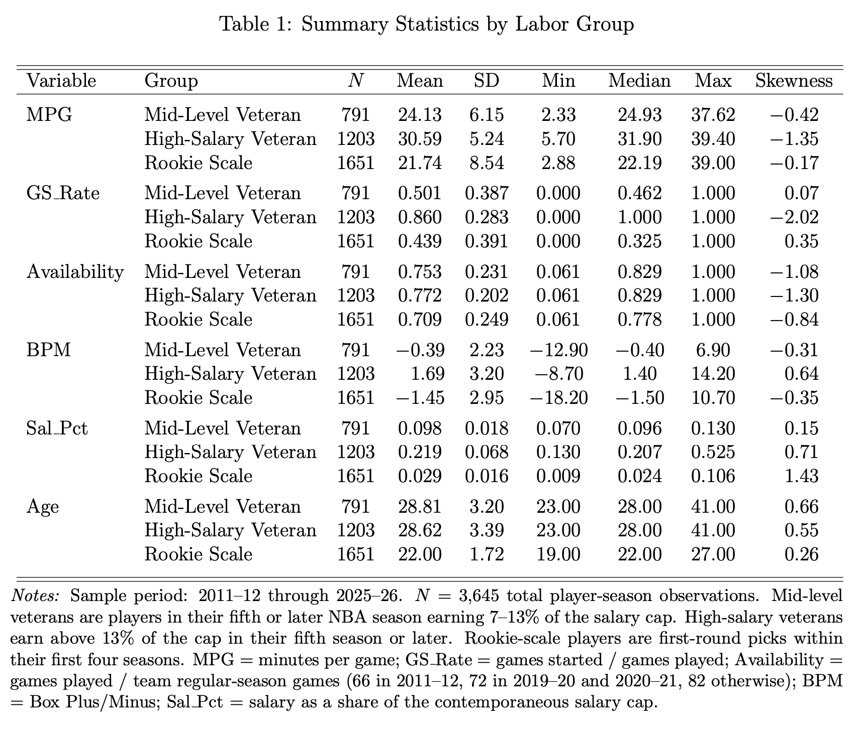
Table 1 presents summary statistics for the full sample and separately for the pre- and post-apron periods. Raw pre/post comparisons for mid-level veterans show a modest MPG decline (24.3 to 23.6), a drop in starter rate (51.0% to 46.7%), and a fall in availability (76.5% to 70.8%). These shifts understate the true decline — the post-apron mid-vet pool is made up of better players on average (BPM improved from -0.47 to -0.06), which naturally stabilizes the raw averages. The regression-adjusted estimates tell the true story; once player quality is held constant, the same player plays meaningfully fewer minutes post-apron than they would have before.
Notably, the number of players falling within the mid-level salary band each season remained relatively stable across the sample; the post-apron shift is not a story about mid-level contracts disappearing, but about who receives them and how those players are utilized. Taken together, the summary statistics paint a consistent picture: the mid-level band is getting younger and better, mid-level veterans are playing fewer minutes, starting less, and appearing in fewer games — changes that are amplified once the simultaneous improvement in player quality is accounted for. This points to a more selective and cost-conscious approach to mid-level investment following the second apron, with teams favoring younger, higher-quality players over established veterans.
Figures 1A and 1B in Appendix B show the aggregate minute share by labor group over the full 15-season sample. Figure 1A shows a modest post-apron decline in mid-level veteran minute share, though the dip begins slightly before 2023, suggesting it may partly reflect a pre-existing trend rather than a clean break at the second apron. High-salary veteran and rookie-scale shares show no consistent directional change. Figure 1B shows the complementary residual share flowing to players outside the estimation sample — minimum salary, two-way contract, second-round, and undrafted players. This share dips just before the second apron and spikes back up post-2023, though the broader pattern appears to reflect a pre-existing trend across the sample period, potentially connected to the first apron's introduction at the start of the sample window in 2011. Individual-level data for this group were not collected, which is a limitation of the current design; a direct analysis of how this group's utilization changed would require player-level contract and performance data for every minimum and two-way player across all 15 seasons. Descriptively, however, the residual pattern is broadly consistent with a rotation shift toward cheaper labor that predates and extends through the second apron.
IV. Empirical Methodology
4.1 Estimating Equations
I estimate the following model separately for each labor group:

where Y(i,t) is MPG, GS_Rate, or Availability; αᵢ denotes player fixed effects; and standard errors are clustered at the team level. Each model is estimated within a single labor group — mid-level veterans, high-salary veterans, and rookie-scale players separately. Era is a dummy variable equal to 1 for seasons 2023-24 onward, capturing the average within-player change before versus after the second apron's implementation. BPM_std controls for performance, ensuring utilization differences are not simply picking up quality differences between eras. Wins_Prior controls for team quality; better teams carry higher-paid rosters and utilize players differently. Multi_Team controls for players traded mid-season.
4.2 Coefficient Interpretation
The primary coefficient of interest is β₁ (Era). Within the mid-level veteran subsample, a negative β₁ means mid-level veterans played fewer minutes per game post-apron, controlling for performance and team quality. Because the same model is run for all three groups, the Era coefficients can be directly compared across groups to assess whether the decline is specific to mid-level veterans or reflects a league-wide shift.
4.3 Identifying Assumption
The central identifying assumption is that the post-2023 shifts reflect a genuine policy response rather than a pre-existing trend. To test this, I re-run the career stage composition analysis using fake cutoff years of 2017 and 2020. No significant shift appears at either fake cutoff (p=0.654 and p=0.647), but the real 2023 cutoff produces a significant result (p=0.005), supporting the interpretation that the changes are driven by the second apron specifically. Teams were also informed of the second apron's rules well before its 2023 implementation, supporting the interpretation that behavioral shifts around 2023 reflect deliberate responses rather than coincidence.
V. Empirical Findings
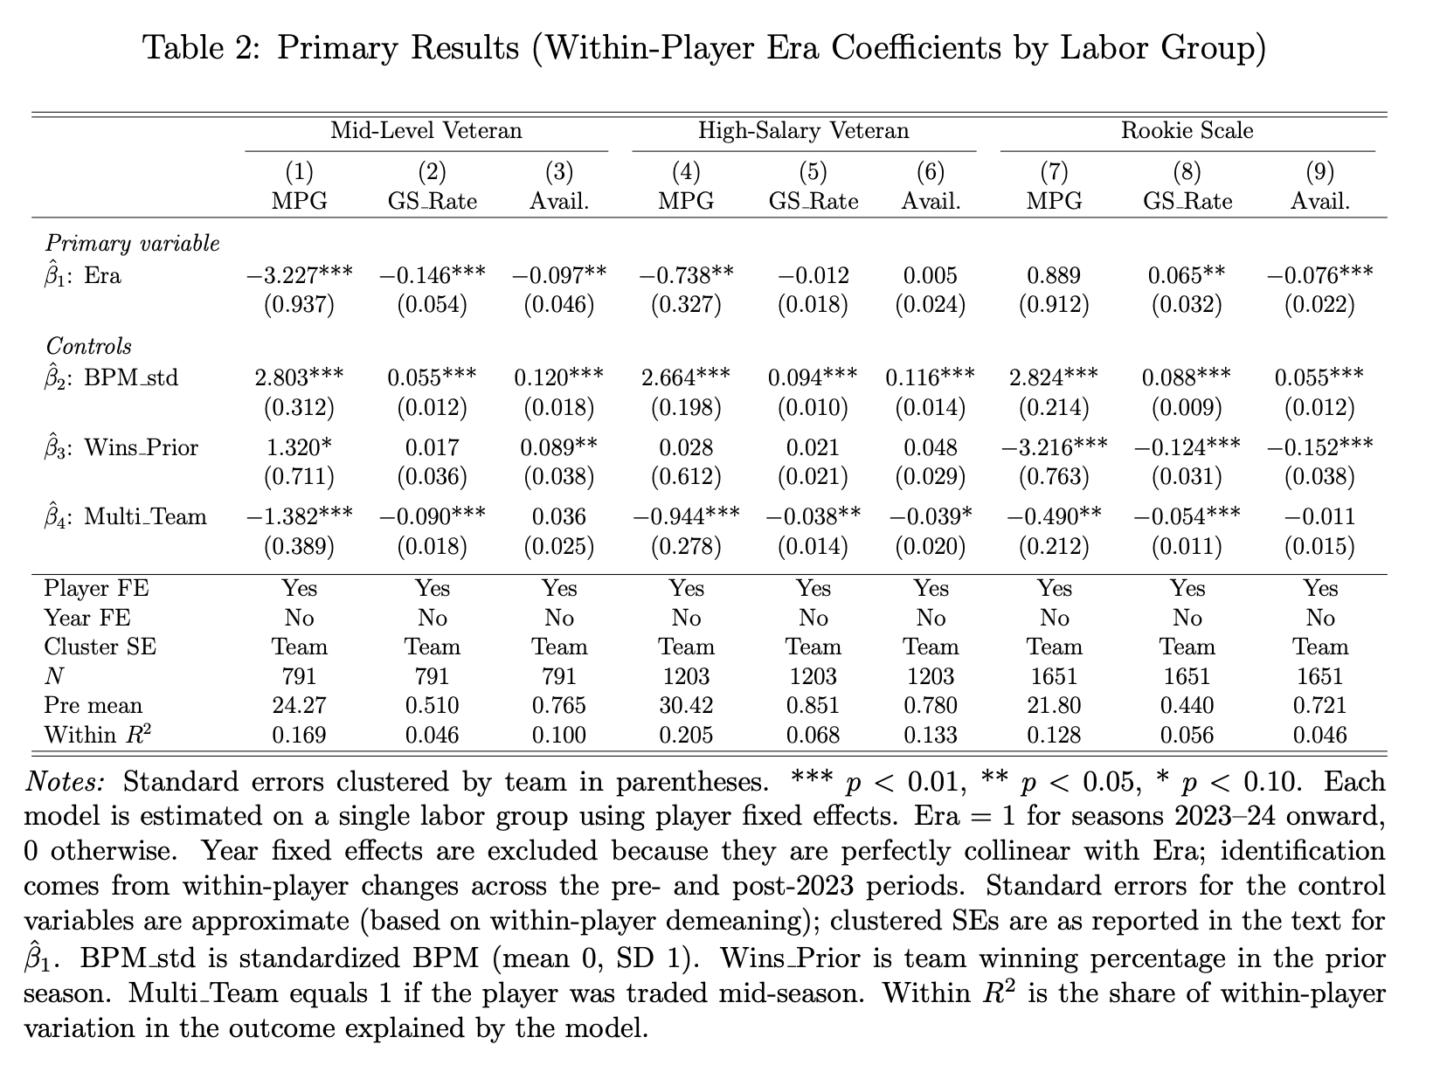
5.1 Layer 1: Mid-Level Veteran Utilization Post-Apron
The primary result is statistically significant (see Table 2). Mid-level veterans lost 3.2 minutes per game post-apron (β₁ = -3.227, p=0.001). This is a meaningful magnitude, and notably stronger than the descriptive decline of just 0.67 MPG. To contextualize the mid-level veteran decline, I run the same model on high-salary veterans and rookie-scale players separately. High-salary veterans also declined post-apron but modestly (-0.738 MPG, p=0.024), with starter rate and availability both unchanged (p=0.512 and p=0.822 respectively). Rookie-scale players showed no significant MPG change (+0.889, p=0.330) and started more frequently post-apron (+0.065, p=0.045), filling some of the starting roles vacated by mid-level veterans. Taken together, high-salary veterans maintained their roles, rookie-scale players gained starting opportunities, and mid-level veterans saw their minutes, starter rate, and availability all decline — consistent with a shift in reliance on cheaper labor.
Figures 1A and 1B (Appendix B) illustrate where those minutes went: the minute share allocated to minimum-salary, two-way, and second-round players rose meaningfully post-apron as the share held by mid-level veterans declined, though both trends appear to begin slightly before 2023, suggesting they may partly reflect pre-existing patterns rather than a clean break at the second apron. High-salary veteran and rookie-scale minute shares show no consistent directional change post-apron. This suggests the minute loss is broadly specific to the mid-level tier, with teams filling those depth minutes with cheaper labor following the second apron.
The availability results add an important layer to this picture. Mid-level veteran availability declined significantly post-apron (-0.097, p=0.035), meaning mid-level veterans are playing in fewer games in addition to fewer minutes per game when active. This stands in contrast to high-salary veterans, whose availability is completely unchanged (+0.005, p=0.822). Load management — the strategic resting of players to preserve health and performance across an 82-game season — has long been associated with high-salary veterans (Weeks and Bhattacharya, 2021). The data suggest a different and more interesting pattern post-apron: high-salary veterans were already being load-managed pre-apron and did not change further, while mid-level veteran availability declined. One interpretation is that load management, previously concentrated at the high-salary level, has spread downward to the mid-tier following the second apron.
The starter demotion test confirms the decline in utilization of the mid-level veteran tier. Mid-level veteran starter rate declined significantly post-apron (-0.146, p=0.007) — a player previously starting 51% of games now starts closer to 37%. This suggests that mid-level veterans are not just playing fewer minutes, but are being placed into entirely different roles. Rookie-scale players showing a significant gain in starter rate during the same period is the direct complement; if a rookie-scale player previously started 44% of the games they played, they are now starting roughly 50.5%. As mid-level veterans are moved to bench roles, some of those starting spots are being filled by players on rookie-scale contracts, consistent with a shift toward cheaper labor.
Splitting the sample into contending and non-contending teams confirms that the decline is happening league-wide rather than concentrated among competitive or tanking teams (see Appendix A, Table 4 for the contender split). The mid-level veteran MPG coefficient is -2.87 on contending teams (p=0.009) and -2.59 on non-contending teams (p=0.009) — nearly identical in magnitude and both highly significant. The decline is not driven by apron pressure on contending teams managing roster costs, nor by tanking teams deliberately benching veterans to develop younger players.
5.2 Layer 2: Compositional Shift Toward Younger Labor
Beyond the utilization decline, the second apron reshaped who occupies the mid-level salary band. The career stage composition of the mid-level veteran group is statistically different post-apron (chi-square p=0.005). The Young share (age 26 and under) of players within the band jumped from 23.2% to 35.5%, while the Prime share (27-30) fell from 47.0% to 38.0% and the Veteran share (31+) declined modestly from 29.8% to 26.5%. The year-by-year breakdown shows this was a consequence of the second apron rather than a trend: the Young/Prime/Veteran split was remarkably stable from 2013 through 2022 — no consistent direction, fluctuating around stable averages — then broke sharply at 2023, with the Young share spiking to 37% in 2023-24 and 42% in 2024-25. Full composition results are reported in Appendix A, Table 5. The year-by-year breakdown is shown in Figure 2B (Appendix B).
Notably, the sharpest compositional decline is in the prime share, falling from 47.0% to 38.0%, despite prime players typically being the highest-performing group within the band. This is not because prime players have become less valuable; rather, as documented in Layer 3, the prime players who do receive mid-level contracts post-apron are substantially better on average. The second apron appears to have raised the performance bar specifically for prime-age mid-level investment, filtering out below-average prime-age players who might previously have received mid-level deals. The pre vs. post career stage mix is illustrated in Figure 2A (Appendix B).
The placebo tests confirm this interpretation. Using fake treatment cutoffs at 2017 and 2020, the chi-square test is completely insignificant in both cases (p=0.654 and p=0.647) — the career stage shares look essentially identical before and after both fake cutoffs. Only the real 2023 cutoff produces a significant result. This is the study's strongest evidence that the composition shift is specifically associated with the second apron policy rather than a continuation of some pre-existing trend toward younger labor.
Critically, this composition shift is driven by changes in who is entering the band rather than who is exiting it. Among players already holding mid-level contracts, exit rates by career stage were unchanged post-apron; veterans have always been more likely to leave the band than prime players (OR=1.793, p=0.003), and young players have always been least likely to exit (OR=0.527, p=0.005), and neither pattern changed after 2023. What changed is who gets offered a mid-level contract in the first place: more young players are entering the band post-apron while fewer prime and veteran players are receiving mid-level deals, suggesting teams are making different decisions at the point of signing rather than managing existing contracts differently. Exit and entry analysis results are reported in Appendix A, Table 5.
The entry analysis confirms this directly. Among first-round picks completing their fourth rookie-scale season, 37.5% entered the mid-level veteran salary band the following year in the post-apron period, compared to 29.3% pre-apron. The 2023-24 season saw 47.1% of year-4 rookies enter the mid-level band — the highest rate in the 15-year sample. A regression of the probability of entering the mid-level band on Era shows a positive but insignificant result (p=0.143), likely reflecting the small post-apron sample of 84 year-4 rookie observations rather than the absence of a true effect.
5.3 Layer 3: Quality and Efficiency
The mid-level players who remain in the band post-apron are substantially better. The value ratio analysis — Box Plus/Minus (BPM) per percentage point of salary cap — reveals a selection effect. Prime-age (27-30) mid-level veteran average BPM jumped from -0.56 pre-apron to +0.43 post-apron, a swing of nearly a full point. By basketball analytics standards, where the gap between a solid starter and an All-Star is roughly 3-4 BPM, this is a modest and meaningful shift. Veterans declined slightly (-0.52 to -0.68 BPM) and young players improved marginally (-0.25 to -0.12 BPM); the prime group's improvement is by far the most notable shift. The average mid-level veteran value ratio was negative in every pre-apron season — meaning the group as a whole consistently delivered below-average BPM relative to its salary cost — before turning positive for the first time in 2024-25 (+3.29 BPM per 1% of cap). The full value ratio trend is illustrated in Figure 3 (Appendix B). BPM and value ratio results by career stage are reported in Appendix A, Table 6.
One interpretation of the Layer 3 findings is that the second apron created a selection effect specifically at the prime-age tier. Teams under greater cost pressure can no longer afford to give mid-level deals to prime-age players who are not clearly above average. This explains why the prime share fell sharpest while the prime-age players who do receive mid-level deals are substantially better post-apron — only the best clear the bar, while the rest are filtered out. The mid-level band is instead being populated by veterans who offer known output, leadership, and experience on shorter team-friendly deals, and younger players coming off rookie contracts who bring developmental upside and roster continuity. Prime players sit in the most difficult position, commanding the highest salaries while offering neither the upside of youth nor the cost certainty and leadership of a veteran.
One might ask whether the BPM improvement simply reflects better players landing in the mid-level band at lower salaries due to cap movement, rather than teams truly becoming more selective about who receives mid-level contracts. A regression of BPM on salary within the mid-level veteran band addresses this directly: the salary-performance relationship within the band did not change post-apron (sal_x_era p=0.358), meaning players are still being priced the same way relative to their output. The overall BPM level within the band rose (era = +0.94, p=0.098), consistent with teams becoming more selective about who they commit to at the mid-level rather than simply absorbing reclassified high-salary players. A regression of BPM on Era across career stages confirms this formally — the overall quality of the mid-level band improved post-apron (+1.37 BPM, p=0.029), with the improvement driven almost entirely by prime-age players.
VI. Conclusion
6.1 Main Results and Interpretation
While the second apron did not crowd out mid-level veterans (in terms of the number of players receiving mid-level contracts), it reshaped the type of mid-level player teams are willing to invest in and how they use them. Mid-level veterans lost 3.2 minutes per game post-apron and started games at significantly lower rates, effects that are uniform across contending and non-contending teams and substantially larger than the modest decline observed among high-salary veterans. Moreover, the players who remain in the mid-level band are better — prime-age average BPM improved by nearly a full point, 2024-25 produced the first positive value ratio in the sample. The mid-level band got younger because teams are increasingly favoring players coming off their rookie-scale contracts over established prime and veteran free agents for mid-level deals. Taken together, the second apron reduced how much mid-level veterans play and the roles they occupy, and shifted the band toward younger, higher-quality players coming off rookie deals.
6.2 Qualifications
Three qualifications deserve explicit acknowledgment. First, the post-apron sample covers only three seasons (2023-24 through 2025-26). While the results are statistically significant and the placebo tests pass, a longer post-apron window would strengthen causal attribution considerably. Second, the Era indicator captures the full set of 2023 CBA changes, not the second apron in isolation. Without year fixed effects, the Era coefficient could in principle absorb other league-wide changes coinciding with 2023. The placebo tests address this most directly, but isolating the second apron's specific contribution from other concurrent changes remains a limitation of the current design. Third, BPM is computed from box score statistics that include minutes played, introducing a potential endogeneity concern in models where BPM_std is used as a control; though the direction of any resulting bias would likely understate rather than inflate the primary utilization estimates.
6.3 Future Directions
Two directions stand out for future research. First, the planned expansion of the NBA to Las Vegas and Seattle will reshape the labor market dynamics documented in this paper in ways worth examining. Adding two franchises dilutes the available player pool across more rosters, potentially making it harder for teams to fill mid-level contracts with the high-quality, younger players that post-apron strategy now demands. If the supply of genuinely productive mid-level players becomes more scarce relative to demand, the selection effect documented in Layer 3 may weaken — teams may be forced to accept lower-quality mid-level labor simply because better alternatives are diluted across more teams.
Second, the NBA is actively pursuing draft lottery reform with direct implications for the findings of this paper. The league has proposed a “3-2-1 lottery” system that would expand the lottery to 16 teams, flatten odds, and penalize the three worst-record teams with fewer lottery balls for the top pick, targeted for implementation as early as the 2027 draft (Charania, 2026). If enacted, this reform would directly reduce the incentive to lose games in pursuit of high draft picks — the strategy that makes accumulating cheap rookie-scale labor so attractive under the second apron. This creates an interesting dynamic relevant to the findings of this paper: if the value of draft capital falls, do teams shift back toward established mid-level veterans, or does second apron pressure continue to push teams toward younger, cheaper labor regardless? Which force prevails will be one of the more interesting dynamics to watch in NBA roster construction over the coming seasons.

References

Basketball-Reference. (2026). NBA player statistics, 2011-2026. Retrieved from https://www.basketball-reference.com
Berri, D. J. (2012). Did the players give up money to make the NBA better? Exploring the 2011 collective bargaining agreement. International Journal of Sport Finance, 7, 158-175.
Charania, S. (2026, April 28). NBA discloses anti-tanking draft reform “3-2-1 lottery” to general managers. ESPN.
Groothuis, P. A., Hill, J. R., & Perri, T. J. (2007). Early entry in the NBA draft: The influence of unraveling, human capital, and option value. Journal of Sports Economics, 8(3), 223-243.
HoopsHype. (2026). NBA salary data, 2011-2026. Retrieved from https://hoopshype.com
Humphreys, B. R., & Mondello, M. (2008). Determinants of franchise values in North American professional sports leagues. Journal of Sports Economics, 9(3), 229-250.
Pradhan, S., & Leshchinskii, D. (2025). Violating the salary cap: Exploring performance gains in the National Basketball Association. Frontiers in Sports and Active Living, 7. https://doi.org/10.3389/fspor.2025.1625458
ShamSports. (2026). NBA salary cap and luxury tax data. Retrieved from http://www.shamsports.com
Simmons, R., & Berri, D. J. (2011). Mixing the princes and the paupers: Pay and performance in the National Basketball Association. Labour Economics, 18(3), 381-388.
SportsBusinessClassroom. (2026). NBA franchise and financial data. Retrieved from https://www.sportsbusinessclassroom.com
Spotrac. (2026). NBA contract and salary data. Retrieved from https://www.spotrac.com
Vaci, N., Cocic, D., Gula, B., & Bilalic, M. (2019). Large data and Bayesian modeling — aging curves of NBA players. Behaviour Research Methods, 51(3), 1379-1393.
Wangrow, D. B., Schepker, D. J., & Barker, V. L. (2017). Power, performance, and expectations in the dismissal of NBA coaches. Journal of Sport Management, 31(5), 473-489.
Weeks, S., & Bhattacharya, H. (2021). Load management in the NBA: Exploring the strategic resting of high-salary players. Journal of Sports Analytics, 7(4), 223-238.
Appendix A: Additional Tables
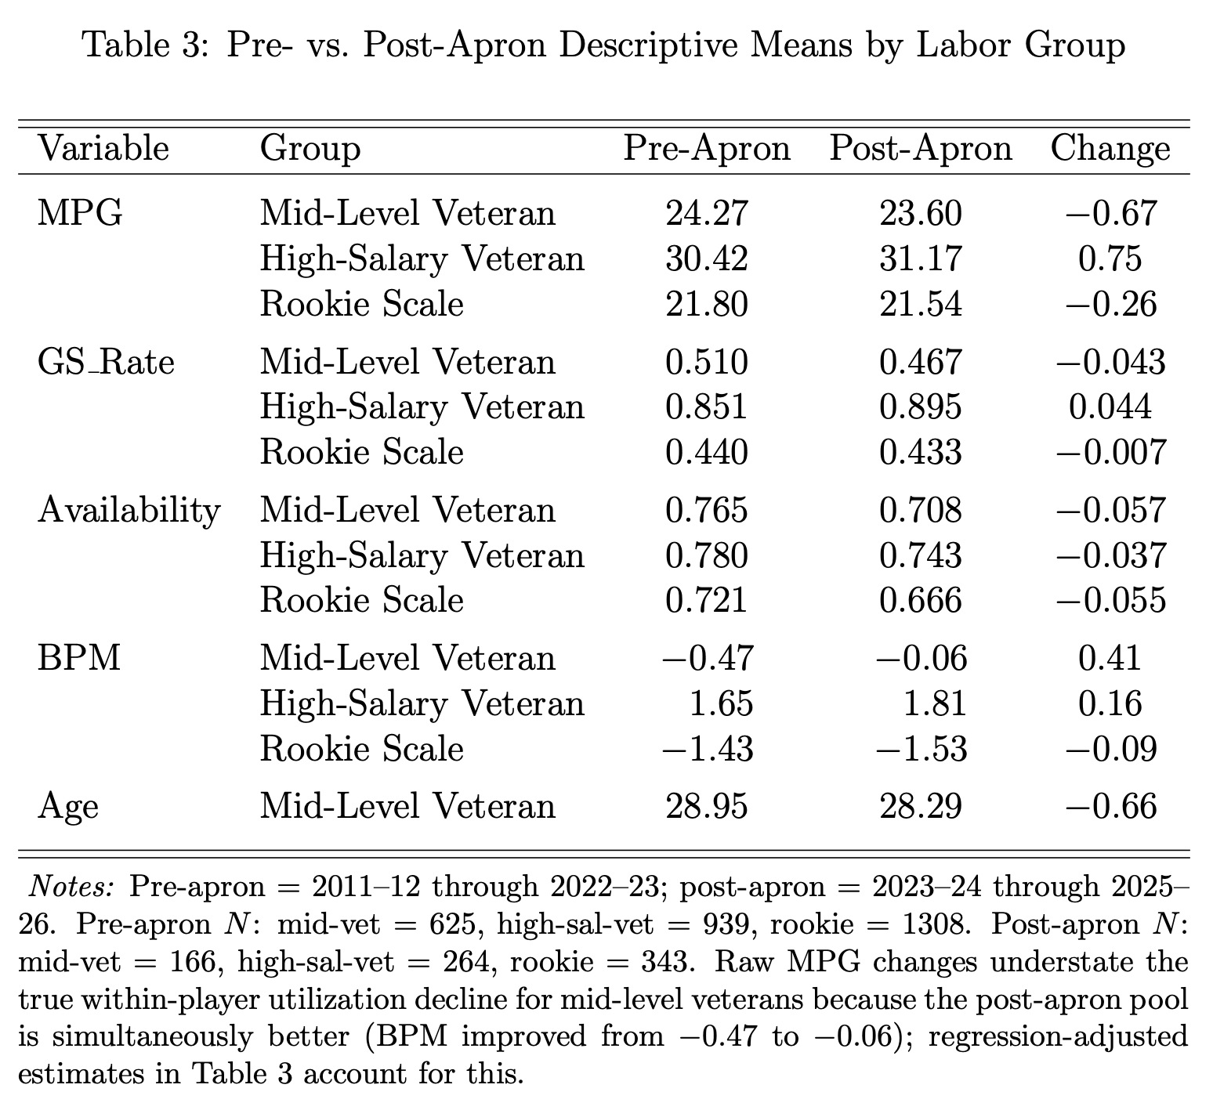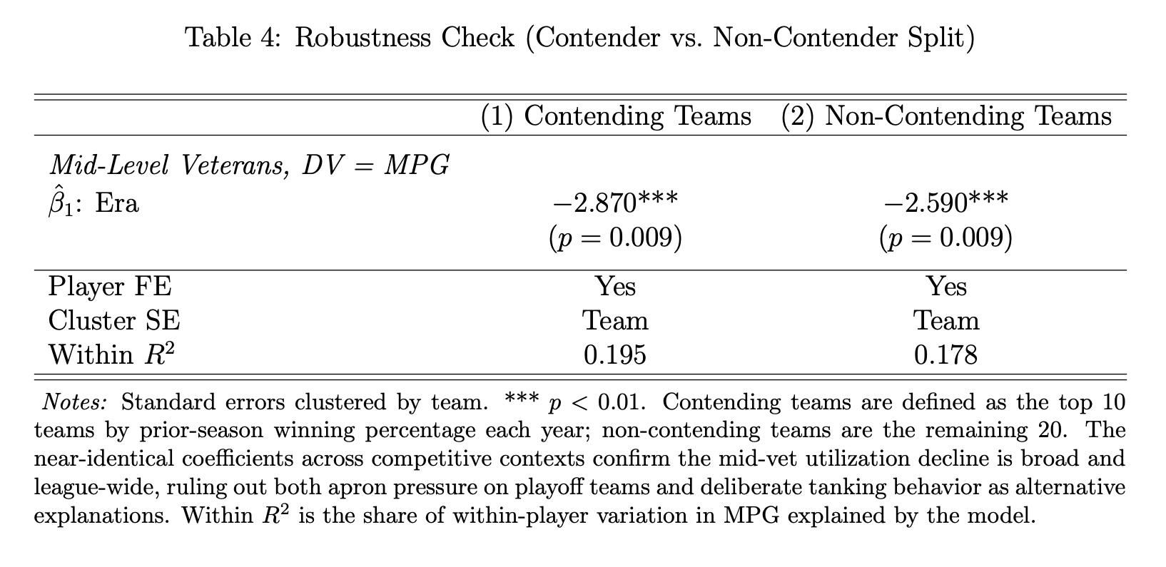
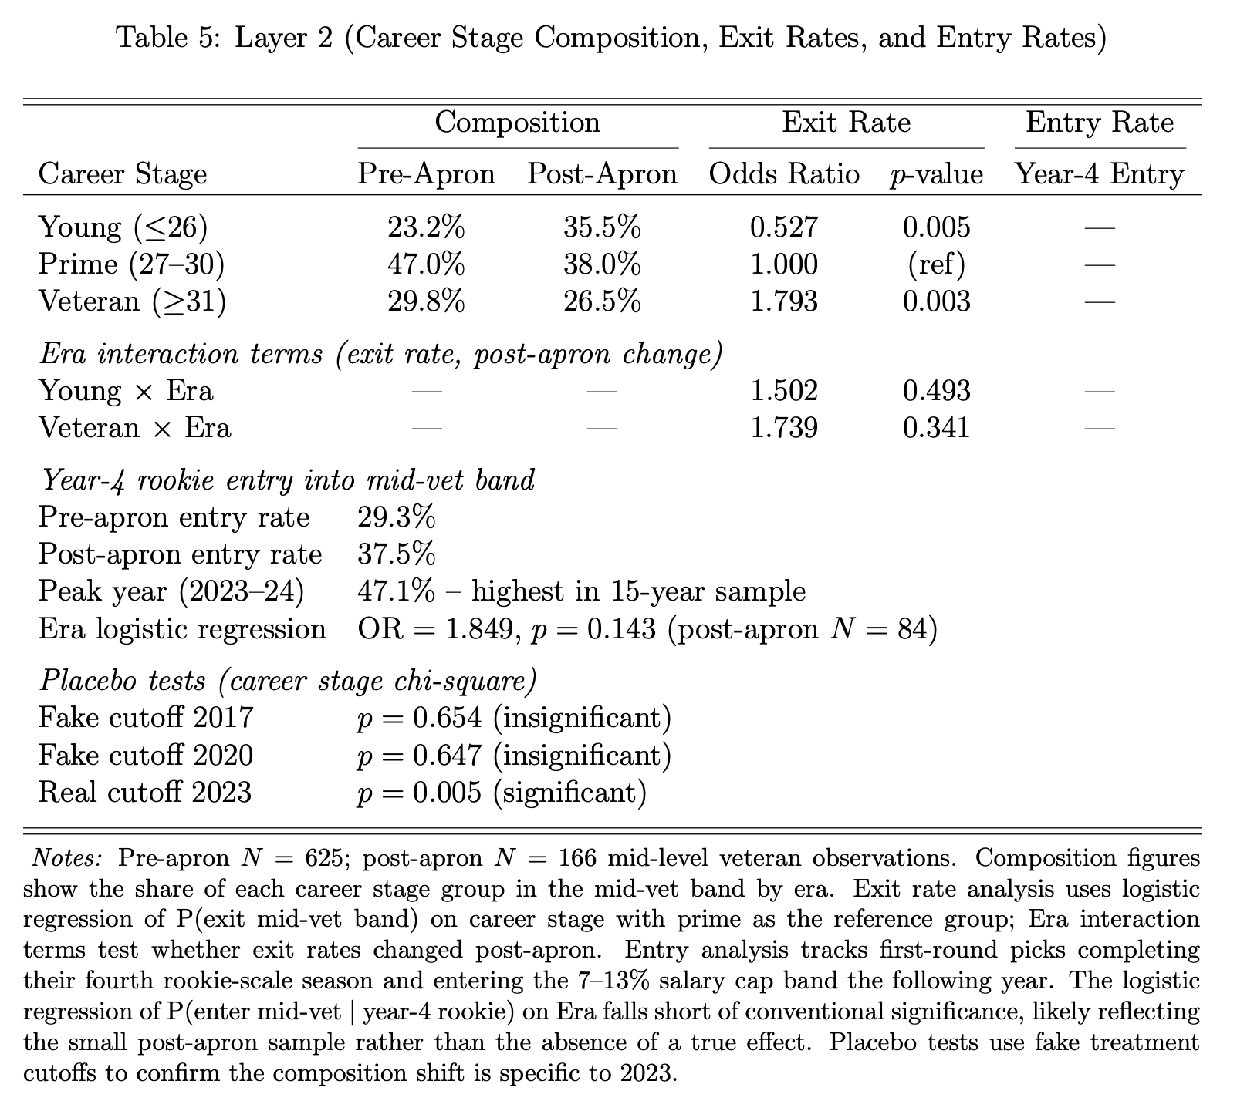
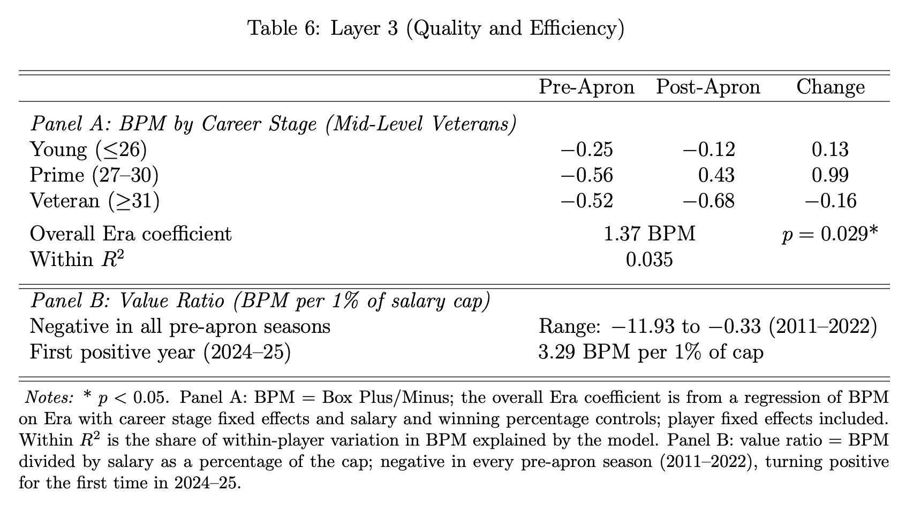

Appendix B: Figures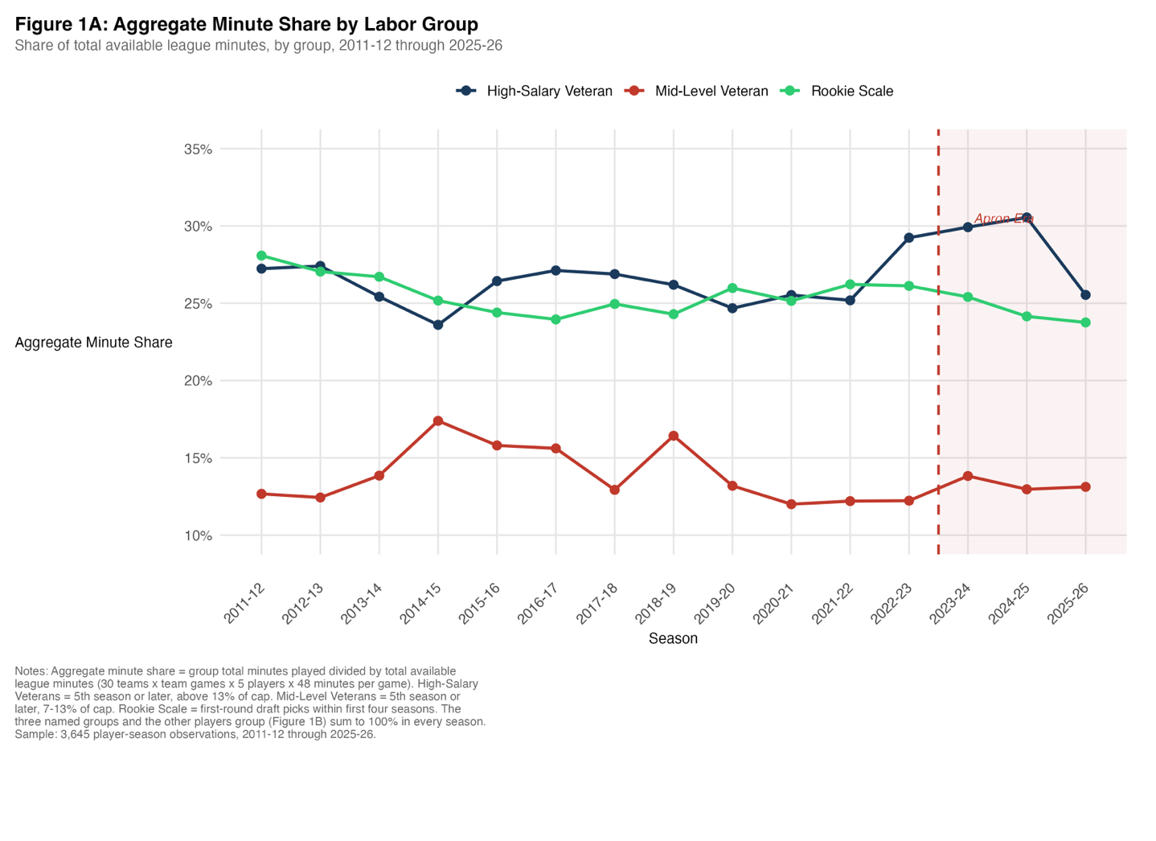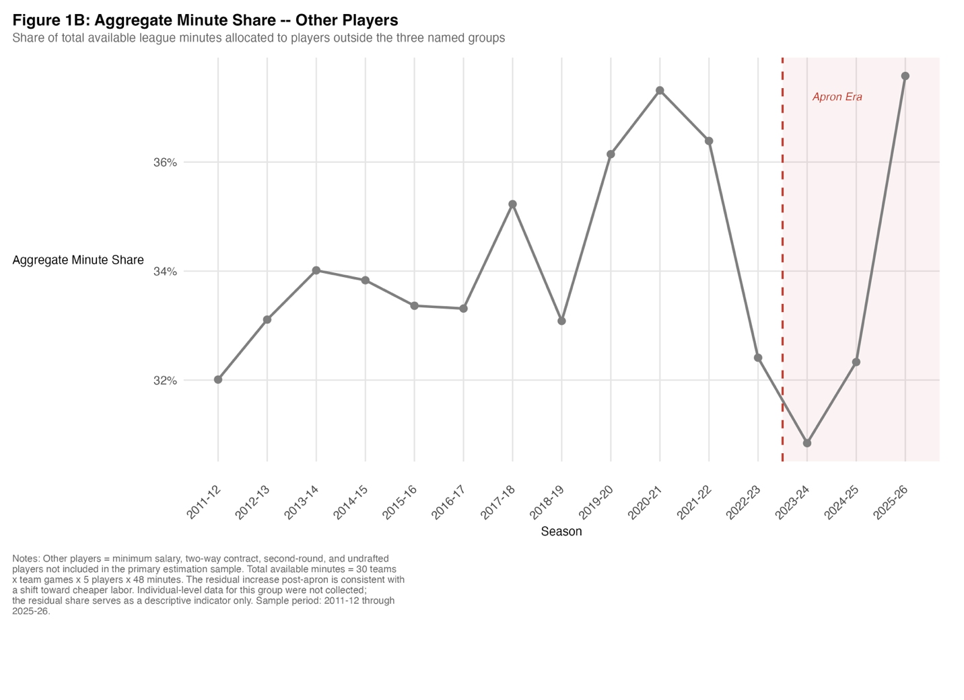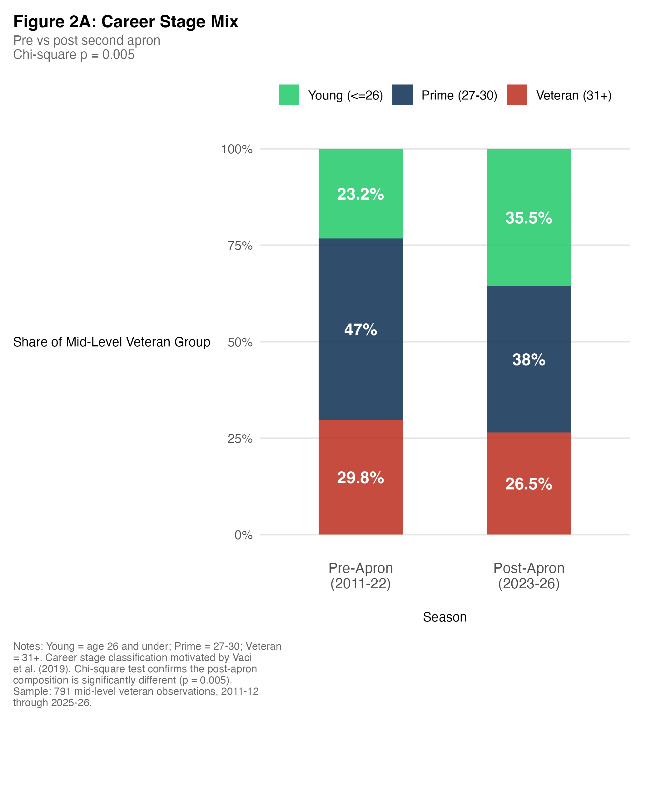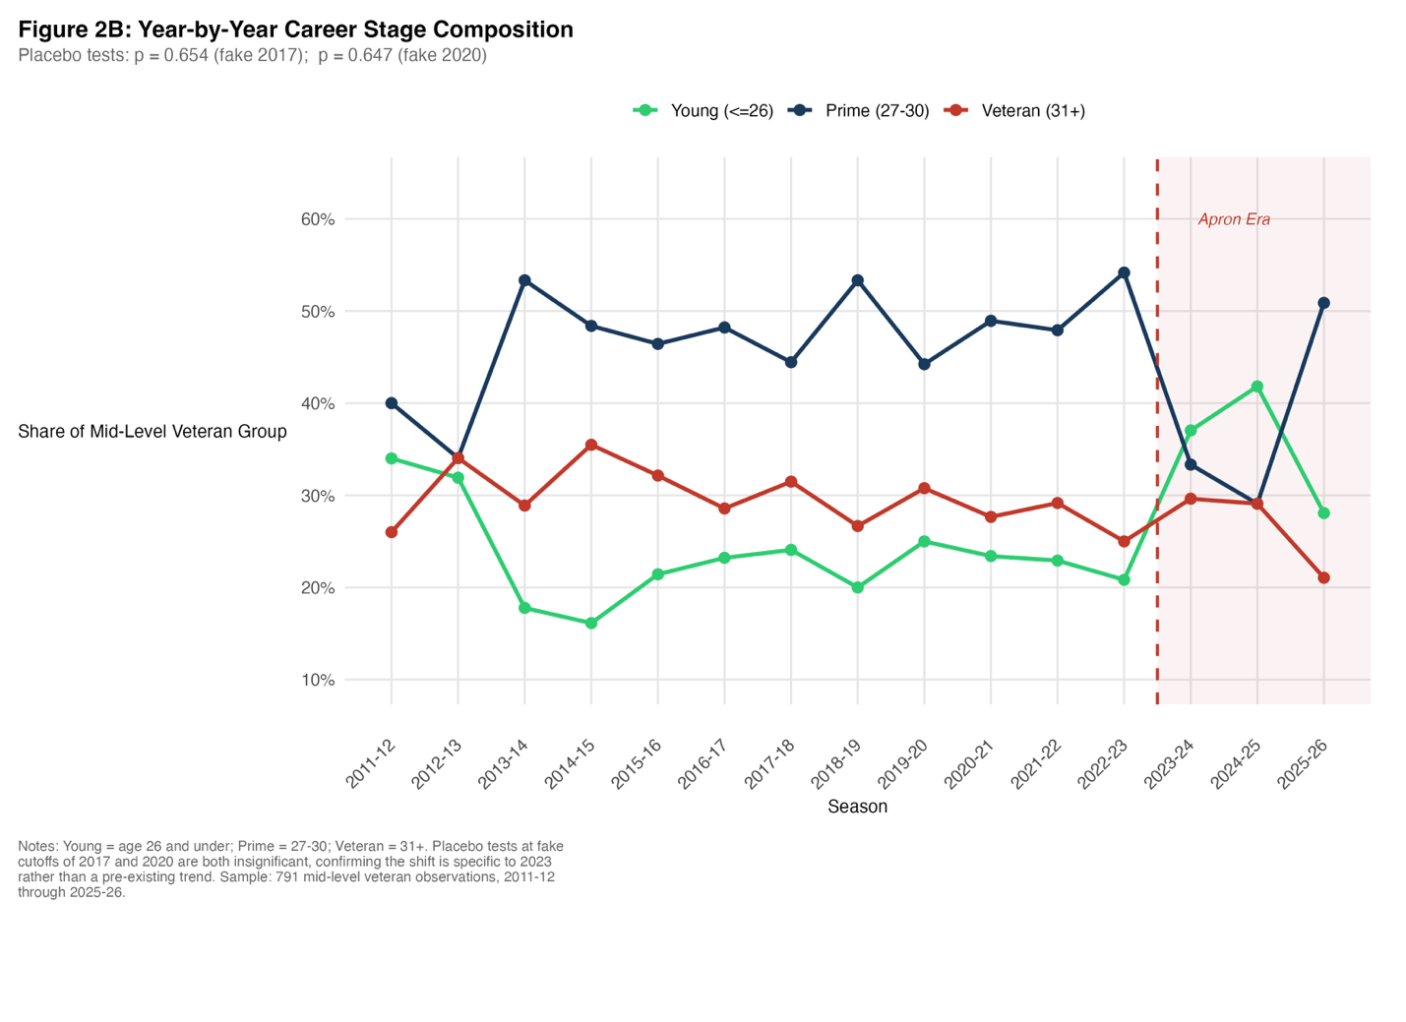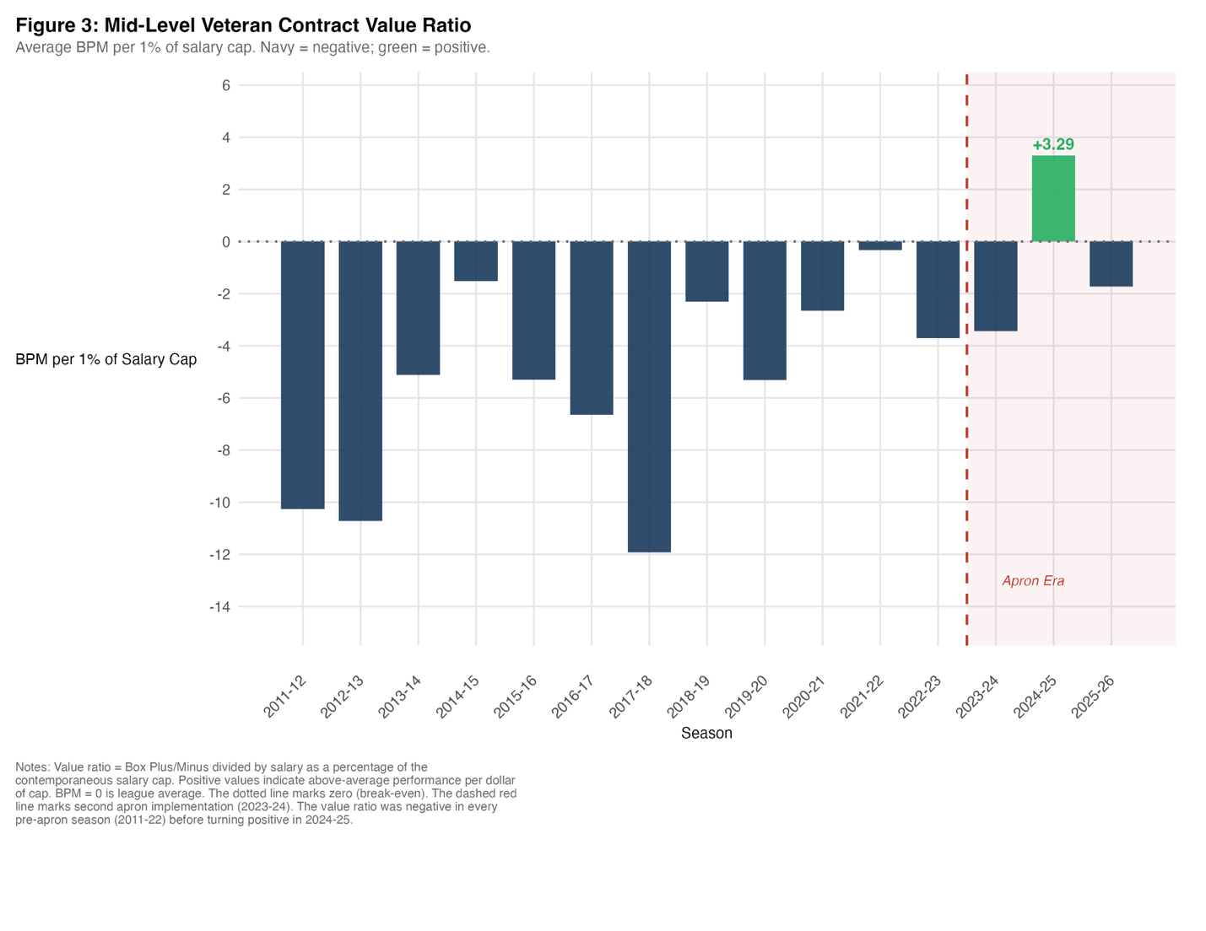
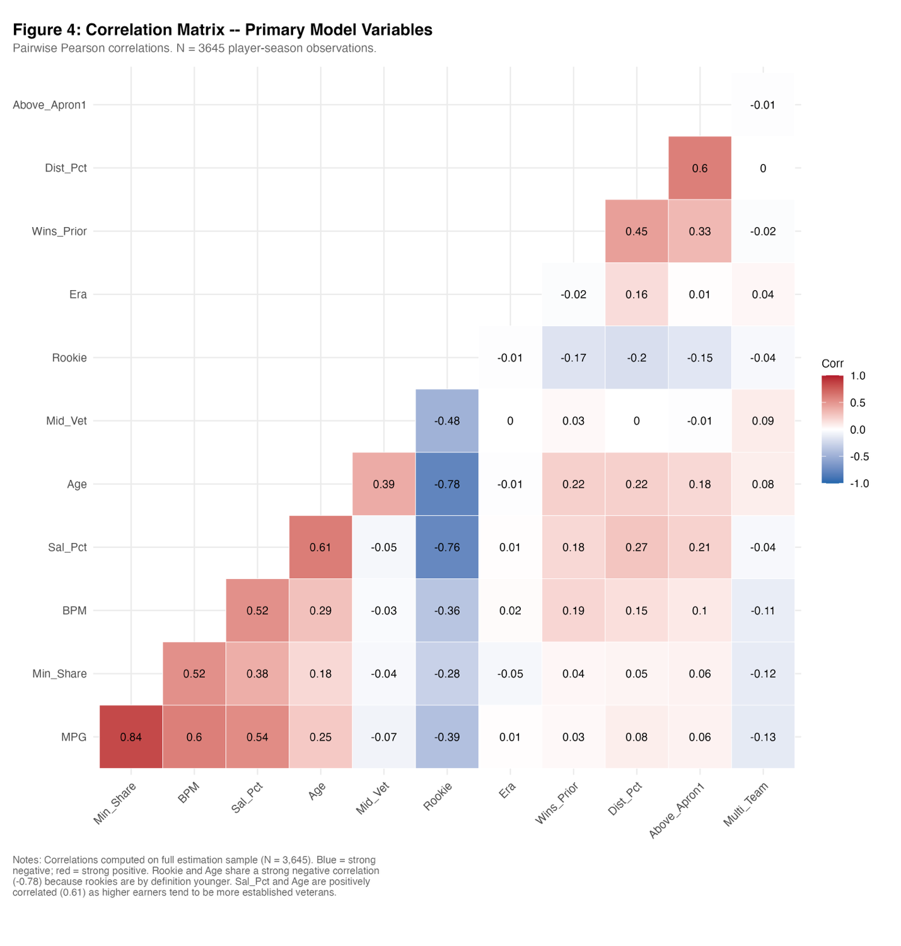

1 Note: In rare cases, a player sustained a significant injury or played overseas while on their rookie-scale contract, meaning the contract year counted toward the deal but did not register as a year of NBA service. Such players appeared within their first four years of service under the filter despite already being eligible for larger extensions and were dropped to ensure only true rookie-scale observations are captured.

